Lifesum App
Although “lifeSum” app is often faced with some hitches, it affords the users access quite a number of benefits. This is irrespective of whether the user is on a free mode or premium mode of the app. Some of the benefits include provision of heathy recipes, promoting community support, hydration management, helpful health tips as well as advice and easy to use food diary technology. Those who want to maintain a healthy living ought to download the app and implement the tips provided to them.
The following foods are selected to create my timetable for meals; Salmon, eggs, kale, chicken, turkey bacon, pancakes, mashed potatoes, rotisserie chicken, spinach salad, buffalo hot sauce wings, black beans, split peas -bannans, apples, blueberries, cherries, rasins/grapes, -almonds, flax seeds -almond milk, water, prune juice.
The next pages show the are some of screenshots of utilization of my food diary using the lifeSum App technology

Breakfast -3rd November 2019
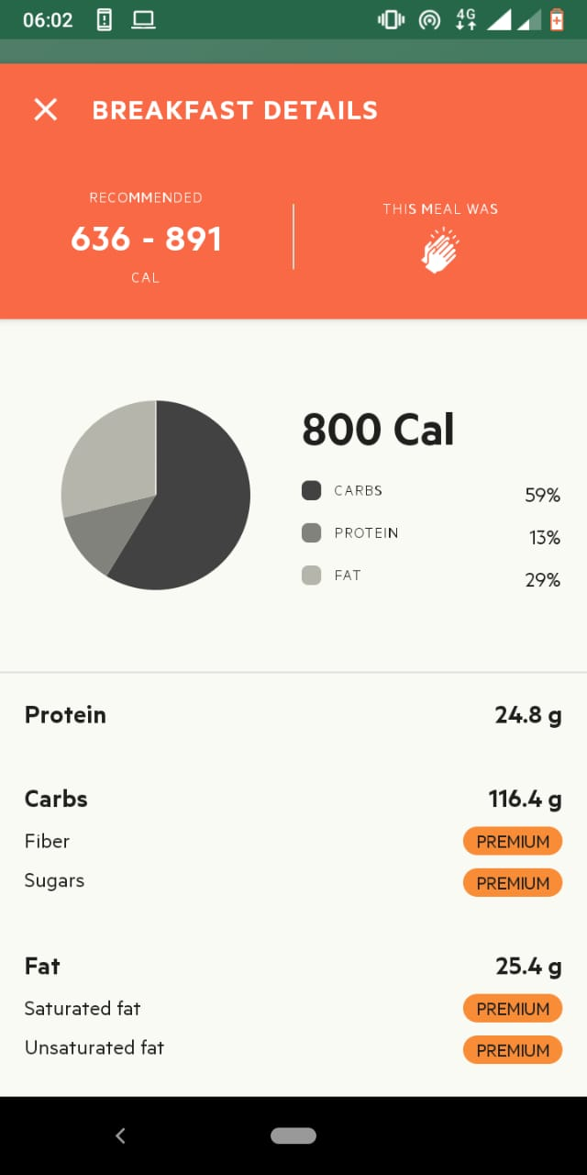

Lunch -3rd November 2019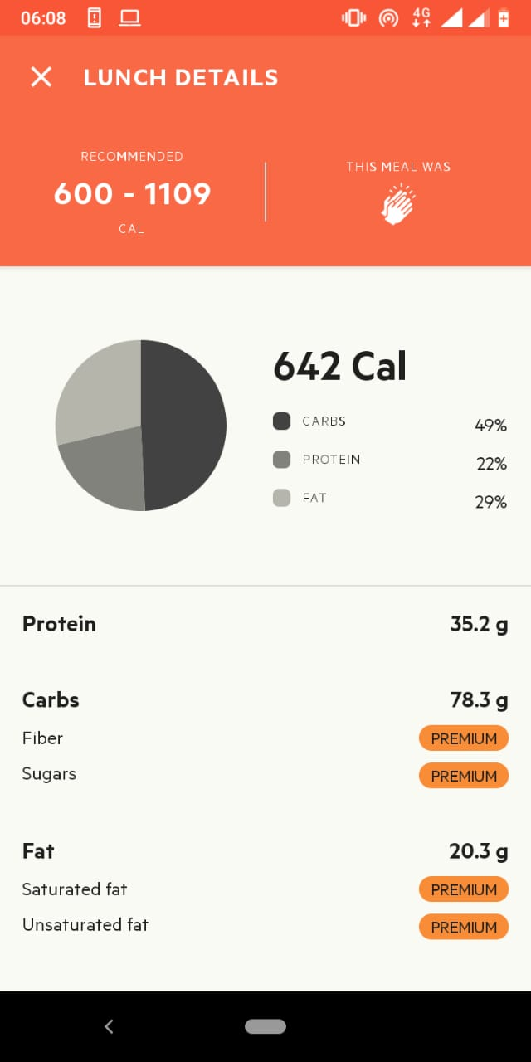
Dinner 3rd November 2019
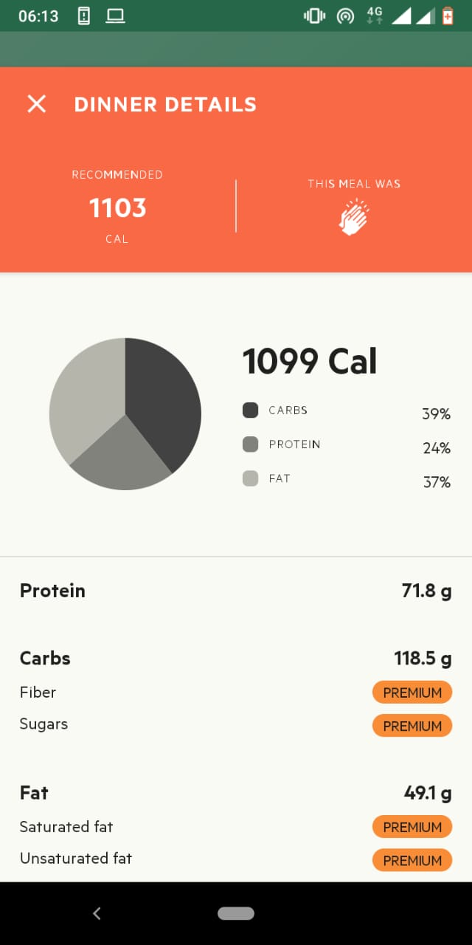
Breakfast 13th November 2019
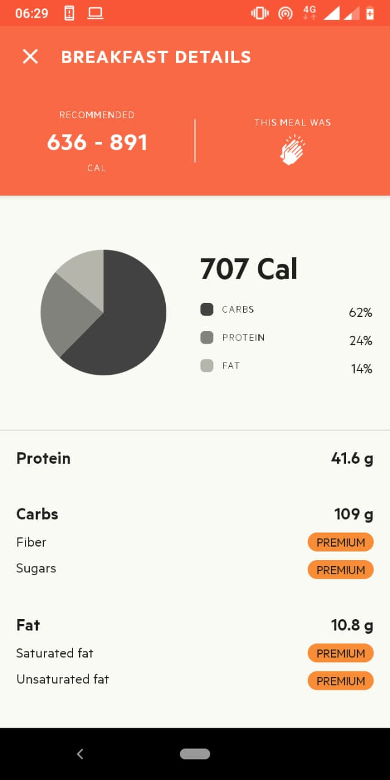

Lunch 13th November 2019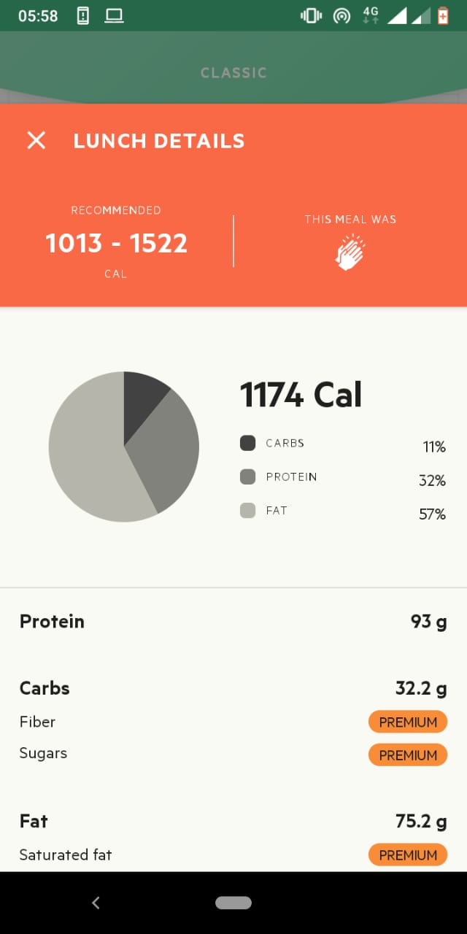

Dinner 13th November 2019
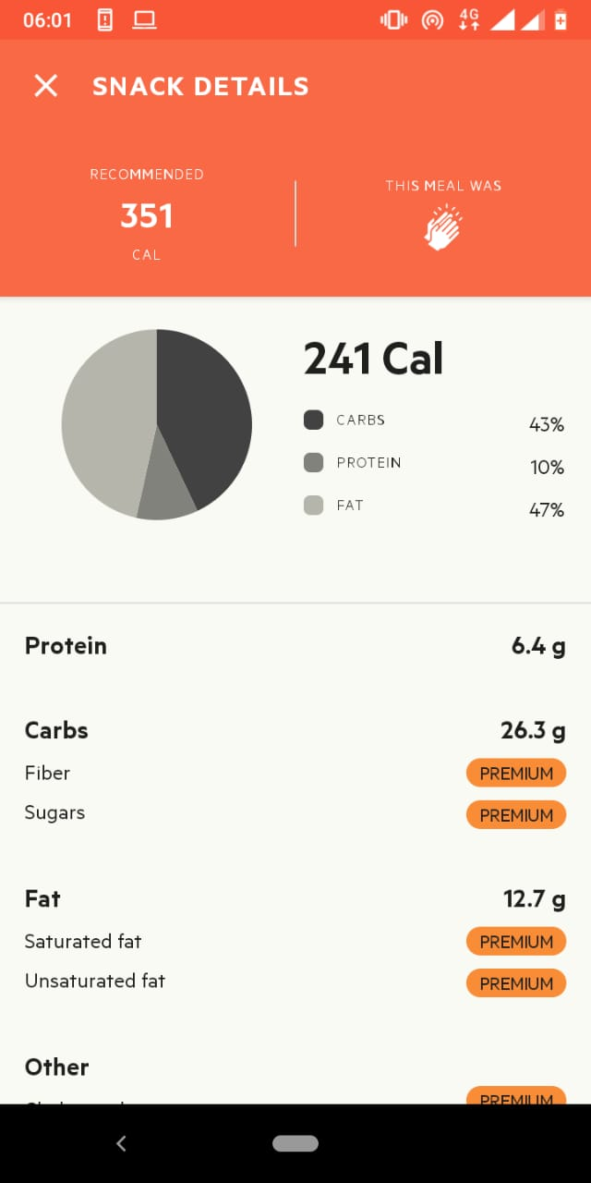

Breakfast 17th November 2019
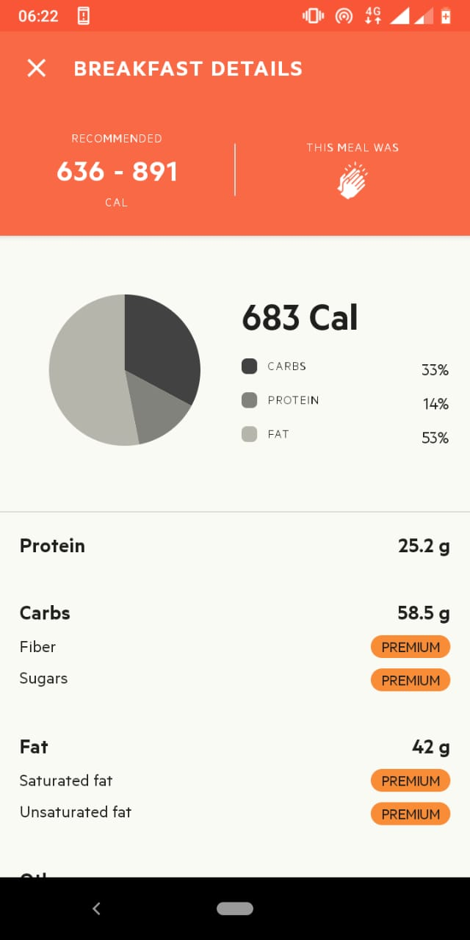

Lunch 13th November 2019
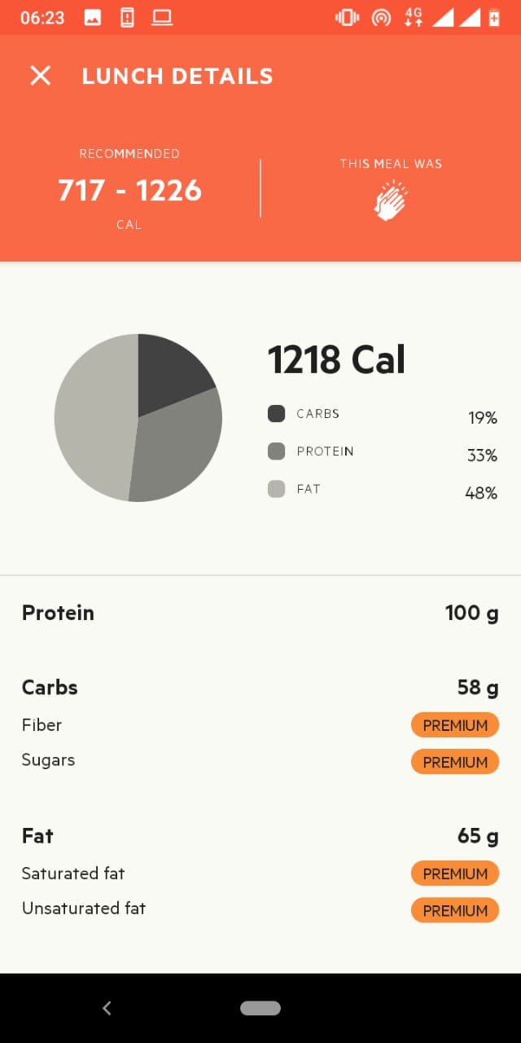

Dinner 13th November 2019
